Wing Ki Chow

Janghoon Yang

CMPSC 132

24 March 2024

Introduction

I build a comprehensive Library Manage System using Python that allows librarians to manage books, patrons, and transactions efficiently. The system should provide functionalities such as adding and removing books, checking in/out books, managing patrons, and generating reports.

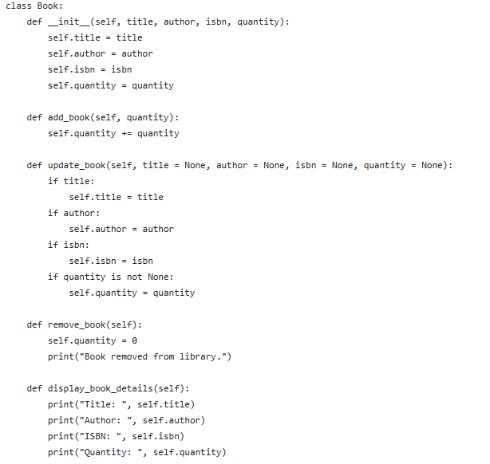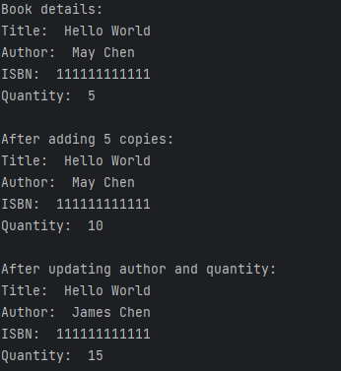

Overview:

The Book class serves as a blueprint for representing books in a library management system. It includes methods for adding, updating, removing, and displaying book details.

Functionality Review:

* Constructor (__init__): Initializes the attribute of the Book object.
* add_book Method: Increases the quantity of books in the library by a specified amount.
* update_book Method: Allows updating the attributes of the book object individually.
* remove_book Method: Sets the quantity of the book to zero, effectively removing it from the library.
* display_book_details Method: Prints the details of the book object.

Strengths:

* The class provides a clear structure for managing book details.
* Methods are appropriately named and encapsulated, promoting code readability and maintainability.
* Constructor initializes book attributes upon object creation.

Improvement:

* Error Handling: Include error handling mechanisms, such as raising exceptions, to handle unexpected scenarios gracefully.

Conclusion:

The Book class provides a solid foundation for managing book details in a library system.

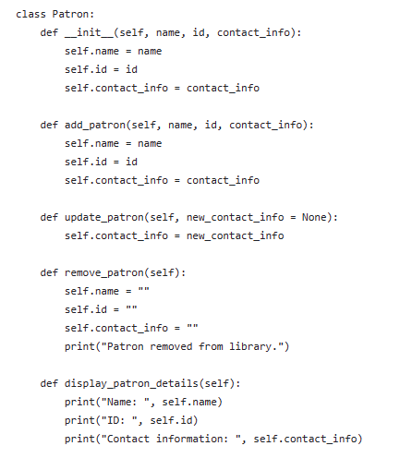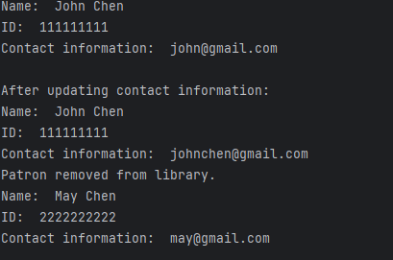

Overview:

The Patron class manages information about library patrons, including their name, ID, and contact information. It provides methods for adding, updating, removing, and displaying patron details.

Functionality Review:

* Constructor (__init__): Initializes the attributes of the Patron object with provided values.
* add_patron Method: Overwrites existing patron attributes with new values, which duplicates the functionality of the constructor.
* update_patron Method: Allows updating the contact information of the patron.
* remove_patron Method: Clears all patron attributes, effectively removing the patron from the library.
* display_patron_details Method: Prints the details of the Patron object.
* Strengths:
* The class provides a basic structure for managing patron details.
* Methods are named appropriately and encapsulated, contributing to code readability and maintainability.

Improvement:

* Refine add_patron Method: Clarify the purpose of the add_patron method. As it stands, it duplicates the functionality of the constructor, which may lead to confusion. Consider either removing this method or providing a clear use case.
* Error Handling: Introduce error handling mechanisms, such as raising exceptions, to handle unexpected scenarios gracefully.
* Documentation: Add docstrings to methods and the class to provide clear explanations of their purpose, parameters, and return values.

Conclusion:

While the Patron class serves its basic purpose, there are opportunities to enhance its functionality, robustness, and usability.

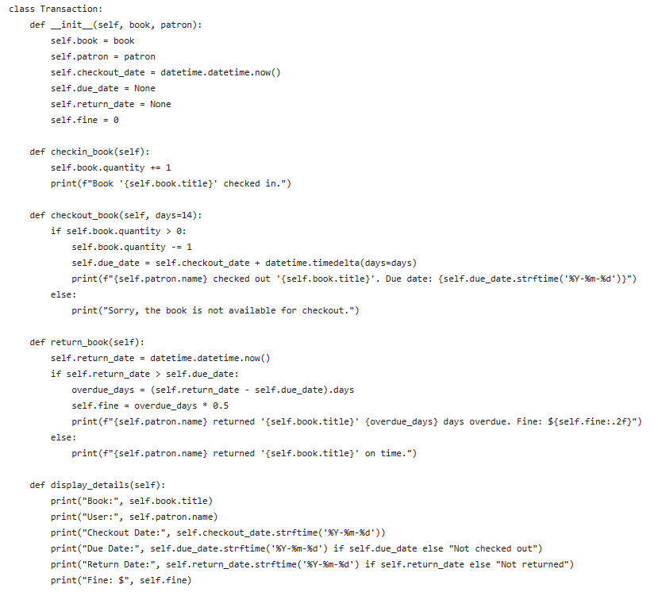

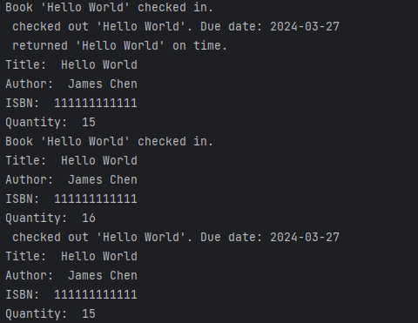

Overview:

The Transaction class facilitates transactions between patrons and books in a library system. It allows patrons to check out books, return books, and provides functionality for managing transaction details such as due dates and fines.

Functionality Review:

* Constructor (__init__): Initializes attributes of a transaction object including the associated book and patron, checkout date, due date, return date, and fine amount.
* checkin_book Method: Increases the quantity of the associated book in the library when a book is returned.
* checkout_book Method: Decreases the quantity of the associated book in the library when a book is checked out, sets the due date for returning the book, and provides feedback to the user.
* return_book Method: Records the return date of a book, calculates fines for overdue returns, and provides feedback to the user.
* display_details Method: Prints the details of the transaction, including book title, patron name, checkout date, due date, return date, and any fines incurred.

Strengths:

* The class provides comprehensive functionality for managing library transactions.
* Methods are well-named and encapsulated, promoting code readability and maintainability.
* Proper use of the datetime module to handle dates and times.
* Improvement:
* Validation: Implement validation checks to ensure that the book being checked out is available in the library, and that return dates are not set before the checkout date.
* Error Handling: Introduce error handling mechanisms, such as raising exceptions, to handle unexpected scenarios like invalid input or database errors.
* Flexibility: Consider adding parameters to methods for handling custom fine rates or checkout periods.
* Documentation: Add docstrings to methods and the class to provide clear explanations of their purpose, parameters, and return values.

Conclusion:

The Transaction class provides a solid foundation for managing library transactions, but there are opportunities to enhance its functionality, reliability, and flexibility.

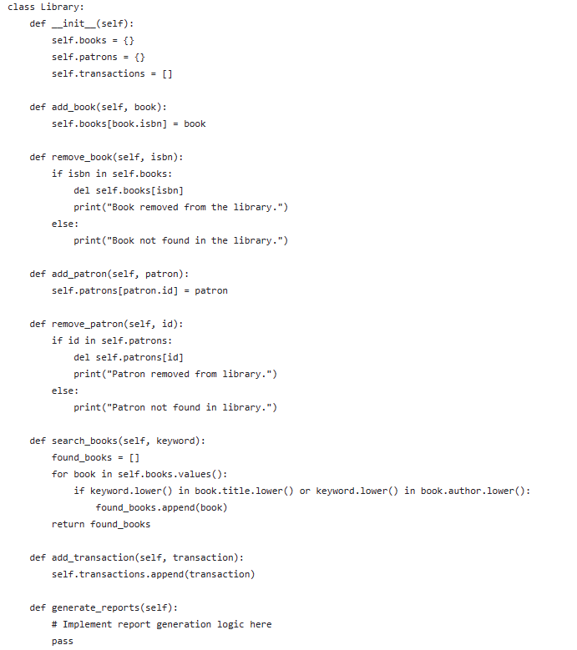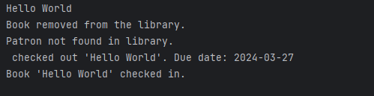

Overview:

The Library class serves as a central component for managing books, patrons, transactions, and potentially generating reports in a library system. It provides methods for adding and removing books and patrons, searching for books, and managing transactions.

Functionality Review:

* Constructor (__init__): Initializes attributes to store books, patrons, and transactions.
* add_book Method: Adds a book to the library by storing it in the books dictionary.
* remove_book Method: Removes a book from the library by deleting it from the books dictionary.
* add_patron Method: Adds a patron to the library by storing it in the patrons dictionary.
* remove_patron Method: Removes a patron from the library by deleting it from the patrons dictionary.
* search_books Method: Searches for books in the library based on a keyword in the book title or author.
* add_transaction Method: Adds a transaction to the library by appending it to the transactions list.
* generate_reports Method: Placeholder for implementing logic to generate various reports related to library activities.
* Strengths:
* The class provides basic functionality for managing library resources and activities.
* Methods are appropriately named and encapsulated, promoting code readability and maintainability.

Improvement:

* Error Handling: Introduce error handling mechanisms to handle scenarios like attempting to add duplicate books or patrons, or searching for non-existent books.

Conclusion:

The Library class provides foundational functionality for managing library resources and activities, but there are opportunities to enhance its features, reliability, and usability.

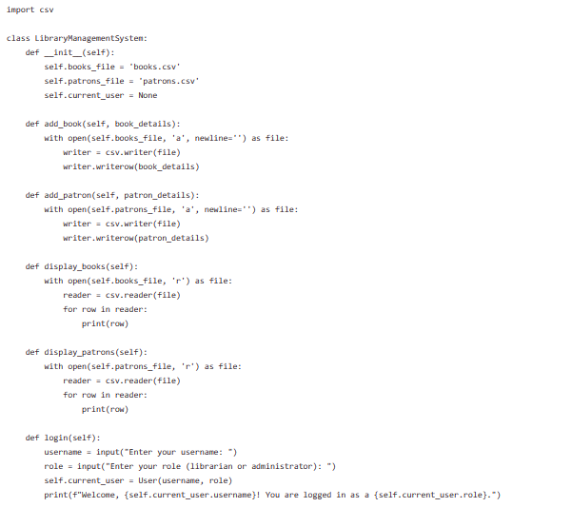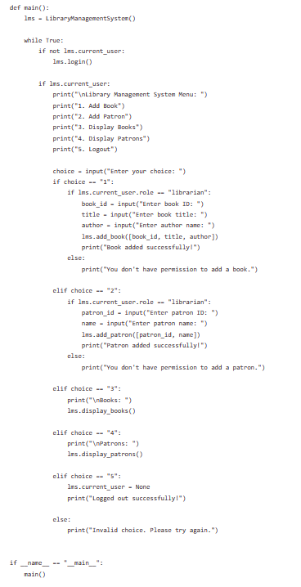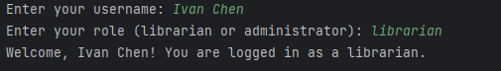

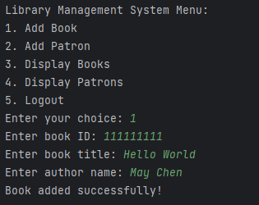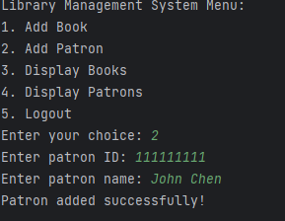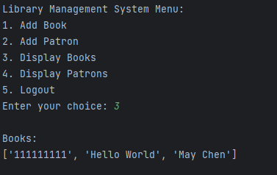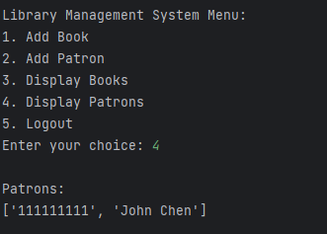

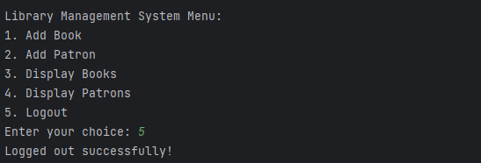

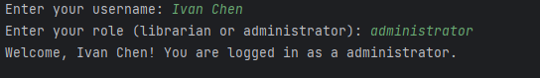

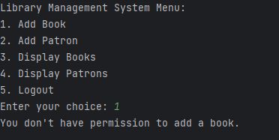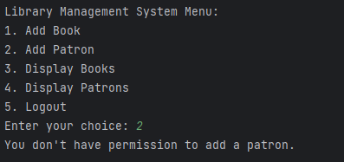

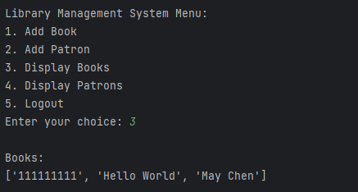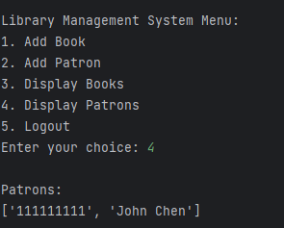

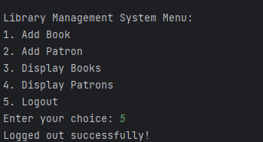

Overview:

The Library Management System (LMS) code provides basic functionality for managing books and patrons using CSV files. It allows users to add books and patrons, display book and patron information, and logout.

Functionality Review:

* LibraryManagementSystem Class:
  + Provides methods for adding books and patrons, displaying book and patron information, and user login/logout functionality.
  + Uses CSV files for data storage and retrieval.
* User Class:
  + Represents a user with a username and role.

Strengths:

* Simplicity: The code is relatively simple and easy to understand.
* Core Functionality: It covers essential features such as adding books and patrons, displaying information, and user authentication.
* Improvement:
* Error Handling: Implement error handling for file operations and user input validation to enhance robustness.
* User Authentication: Enhance user authentication mechanisms, possibly including password authentication.
* Logout Confirmation: Provide a confirmation prompt before logging out to prevent accidental logouts.

Conclusion:

The provided Library Management System code offers a good starting point for managing library resources. However, it can be further improved by implementing error handling, data validation, enhanced user authentication, modularization, and logout confirmation.

Discuss:

This is my first time doing a big project with an interface. The challenges I faced I don’t know how to fix my coding. I always need ChapGPT to help, I think I need to focus more on coding with small stuff, such as (), so I need to improve it.